Parth Chandgadhiya 300986134

Linux Assignment 1 – Laxmi Govinda

Answer 1: -
List all the users who are currently logged on. Save the list in a separate file “logged_users” and display.


Answer 2: -
display the weekday name
display the date in MM/DD/YY format
display the date in YYYY-MM-DD format
display time in HH:MM:SS format

Answer 3: -
access permission
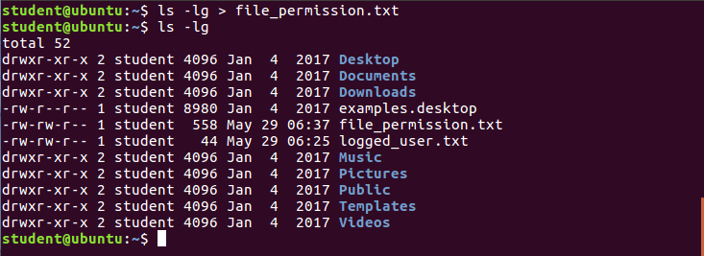

Answer 4: -
the different METHODS to create the files myfile1, myfile2 and myfile3 in a folder called “MYFOLDER”

touch method

cat method

Vi method


Answer 5: -
one single command display the output of “who” and “pwd” commands.


Answer 6: -
a) Search for “Elohim” and present it.

b) Count the number of lines, characters, bytes, words in the above paragraph.

c) Copy the contents into demo_file02, Merge demo_file01 and demo_file02 and name it as demo_file03.
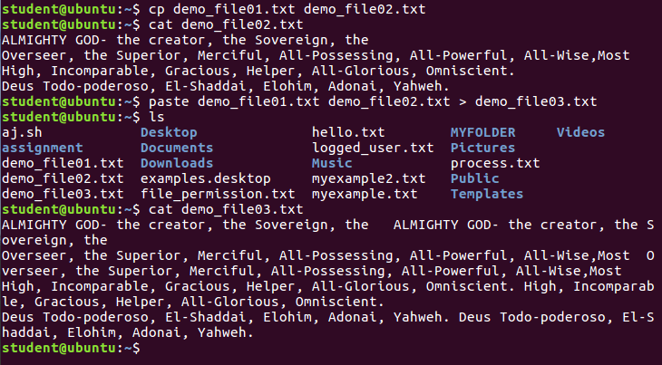
d) Compare the files demo_file03 and demo_file01 and present the difference in the form of line number and character number.
e) Display the first line of the file demo_file02, and the last line of the file demo_file03.


Answer 7: -
Get the status of all the processes running on the system? Save it as a separate file and show its contents.


Answer 8: -
A) Without using a text editor, put the files called ‘f1.txt’, ‘f2.txt’, ‘f3.txt’ and ‘f4.txt’ in it.
b) Set the permissions of ‘f1.txt’ to -rwx r-- r--c) Set the permissions of ‘f2.txt’ to -rw- r-x r—d) Grant the read and execute permissions to file ‘f3.txt’ using numeric method.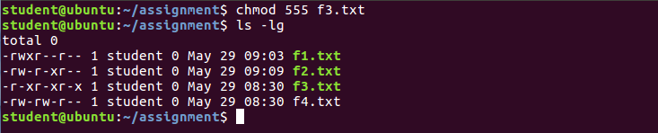e) Grant only the write permission to ‘f4.txt’ using numeric method.

Answer 9: -
1) to write the file.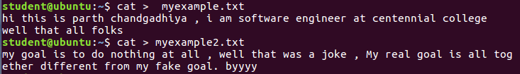
2) as an operator to append the files
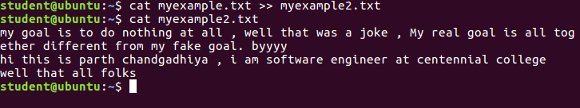

Answer 10: -
How to compress the files: gzip (zipping and unzipping again)s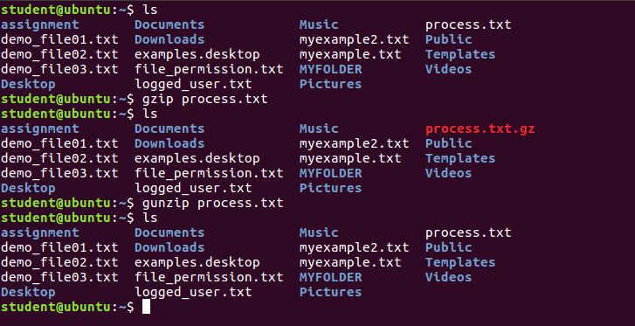What is Command grouping? ANS using multiple command at once
Command grouping : group of commands to be executed as a unit.
Commands can be grouped with help of ”;” and {}


